Sample letter developed by Fuel to Go & Play®
This template for sourcing fruit and vegetable donations is editable, throughout the letter, you will find ‘green text’ where information can be inserted and/or deleted. Delete this box.

[Your Name] Insert club logo
Address
CITY, STATE, POSTCODE
Email or Phone number

Date

Name of person you are writing to
Title of the person you are writing to (e.g. store owner/manager)
[Store Name]
Address
CITY, STATE, POSTCODE

Dear [insert name]

I am the [role at club] at [club name]. I am writing to seek your support in our objective to provide fresh fruit and vegetables to our players. Playing sport is great for health and wellbeing, and the right fuel helps get the best performance.

Although we fully understand you must receive many requests from local organisations, we hope your generosity can extend to support us in creating a healthy food and drink environment for our club members and the wider community.

We have recently been successful in receiving a grant from Healthway as part of their Healthy Sports Program. The program strives to create environments that support players to Grab the Good and fuel up with healthy foods and drinks. Our club is proud to be a Healthy Club and prioritises the health and wellbeing of our members by ensuring everyone has access to healthy options. With the funds we have received and with support from the Fuel to Go & Play® team we will have the opportunity to increase the availability of healthy items. We will be purchasing equipment such as [bench top display fridge, soup kettle, smoothie makers, water bubbler….]

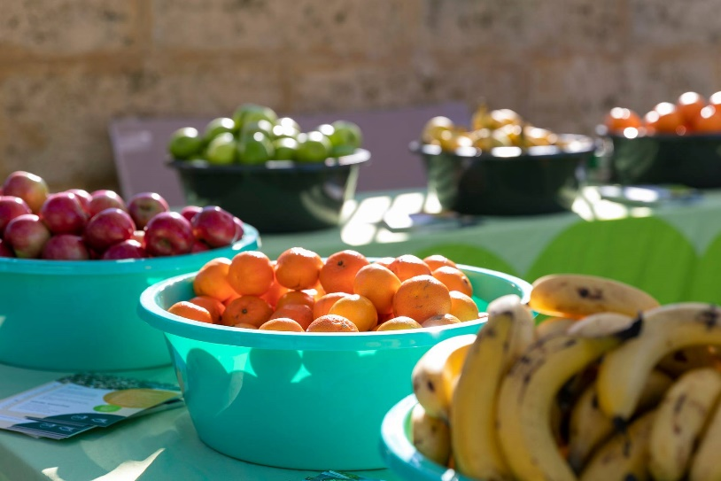
We are hoping that your organisation would be in a position to provide us with a box of seasonal fruit and/or vegetables for nominated game and training days for our players. Of course, we would gratefully acknowledge your valuable contribution on our social media pages and various other opportunities.

We welcome your support and look forward to discussing this with you.

Thank you for your time.

Kind regards
(Your signature)
(Your name)

